Name : Mriganka Patra
Email ID: mriganka.patra@cognizant.com

Task 1: Create New Campaign named 'Summer Product Launch 2025' and add 3 Leads to the Campaign.
- Navigate to the Campaigns tab in Salesforce.
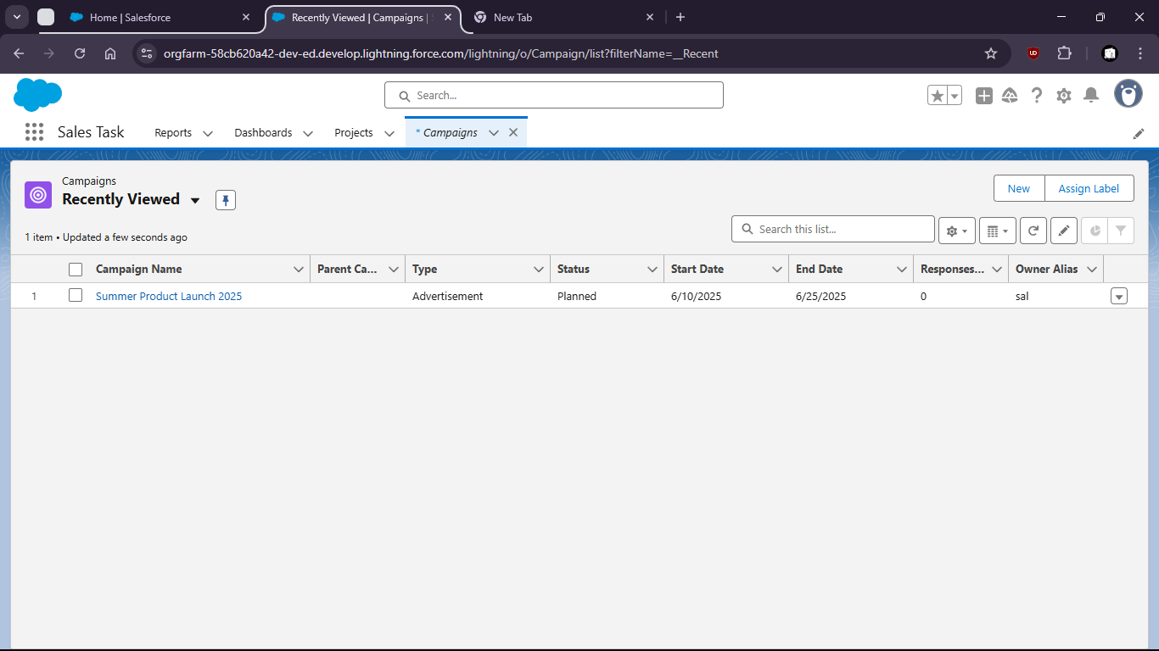
- Click on New
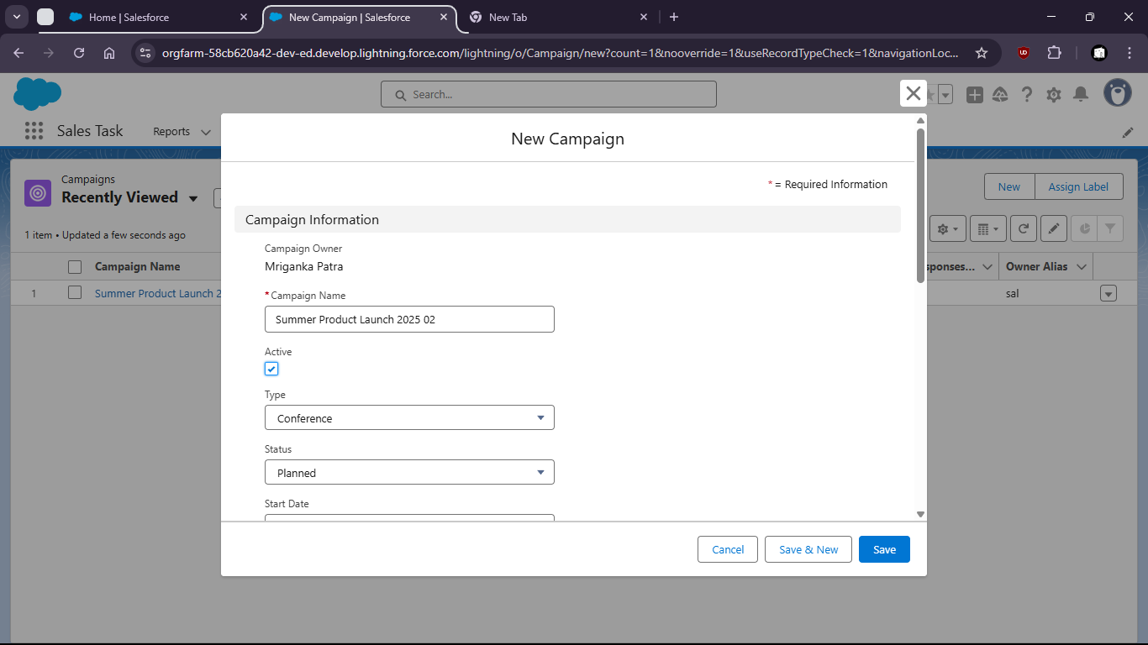
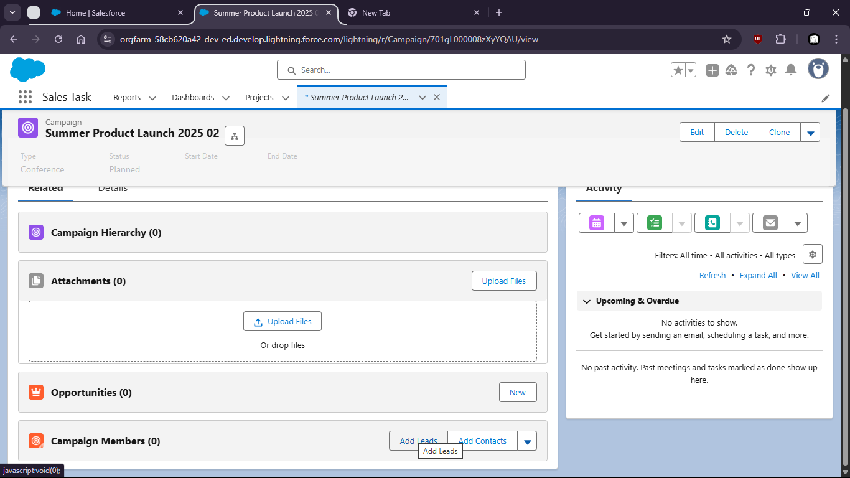
- Click on New Lead
- Lead 1
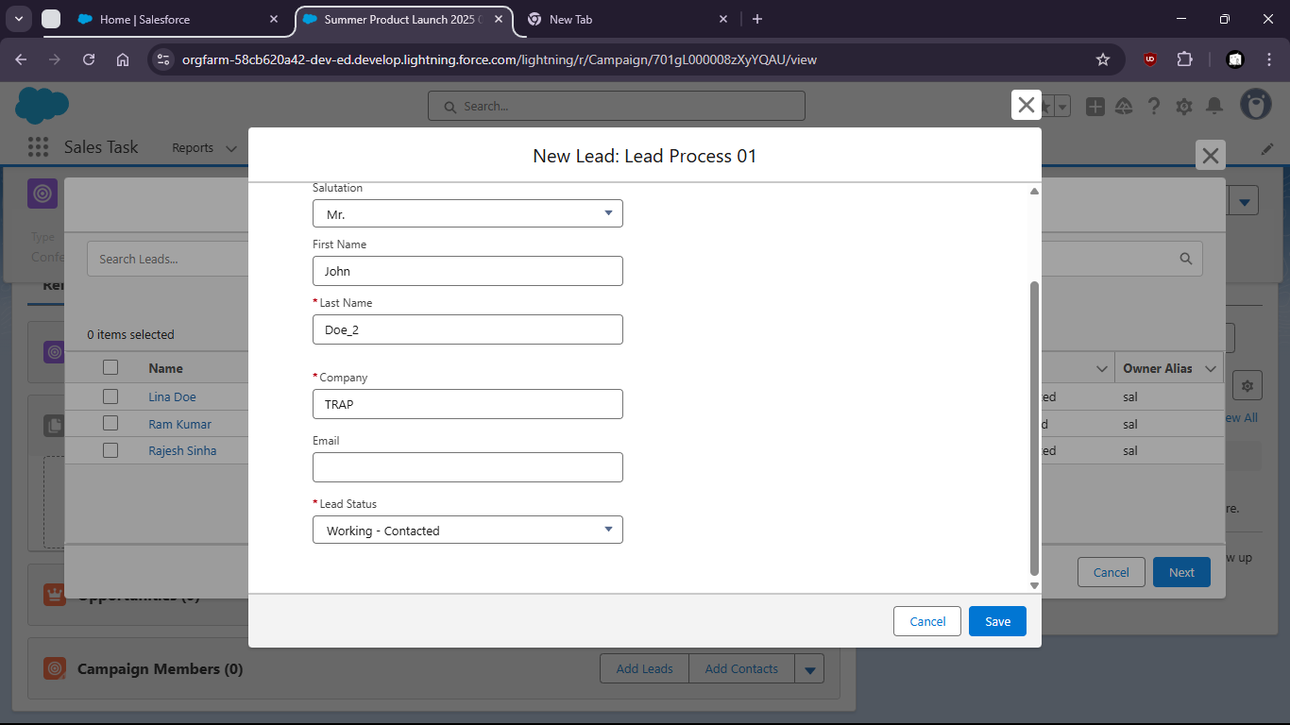
- Lead 2
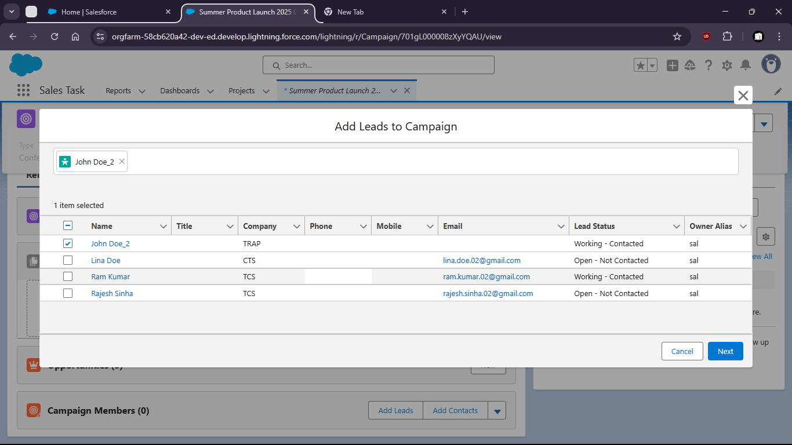
- Lead 3

- Now click on Add Leads under Campaign members
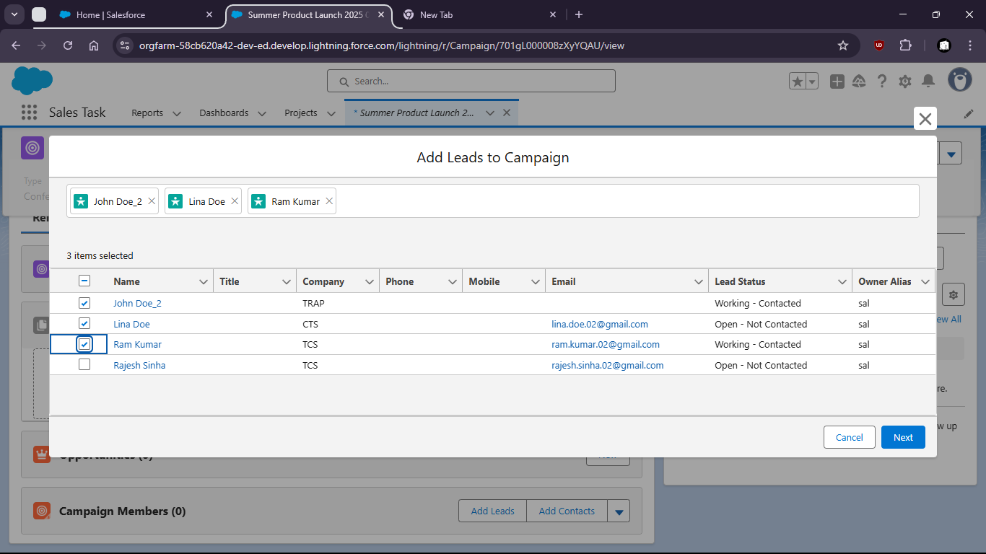

- Select the Leads and click next
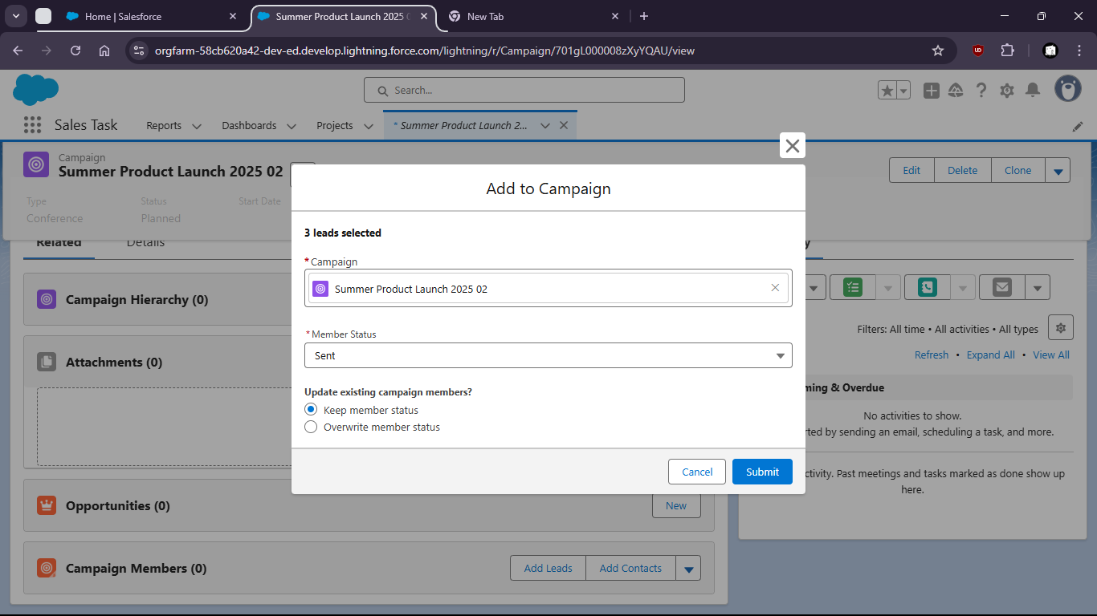

- Leads added
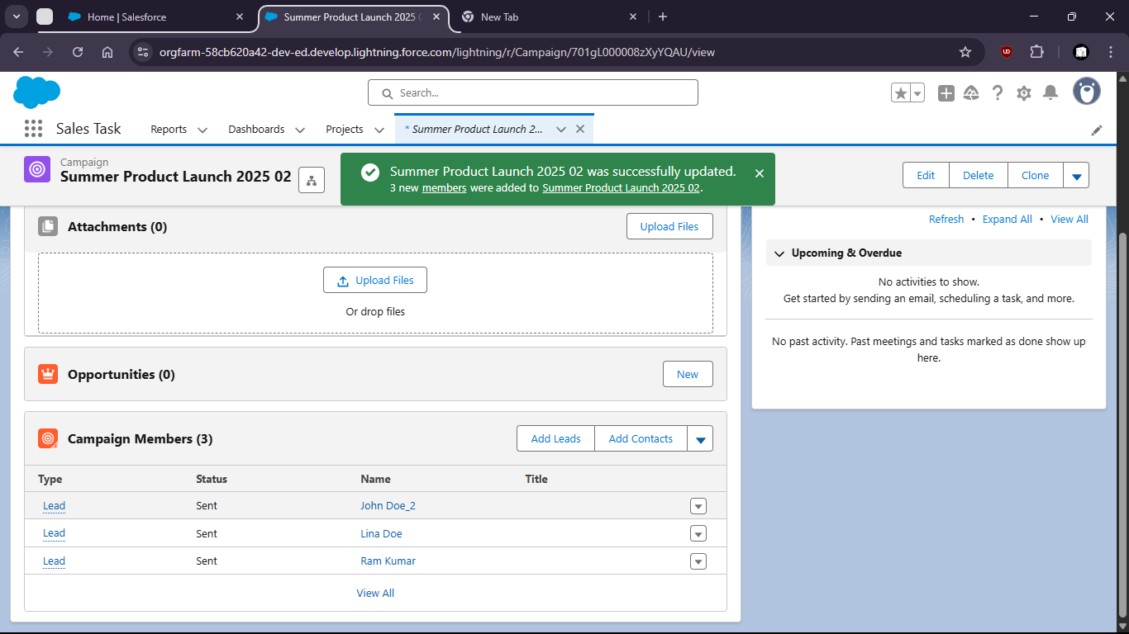

Task 2: Track Campaign influence and status changes across the Sales funnel.
- Go to the App Launcher and search for Reports

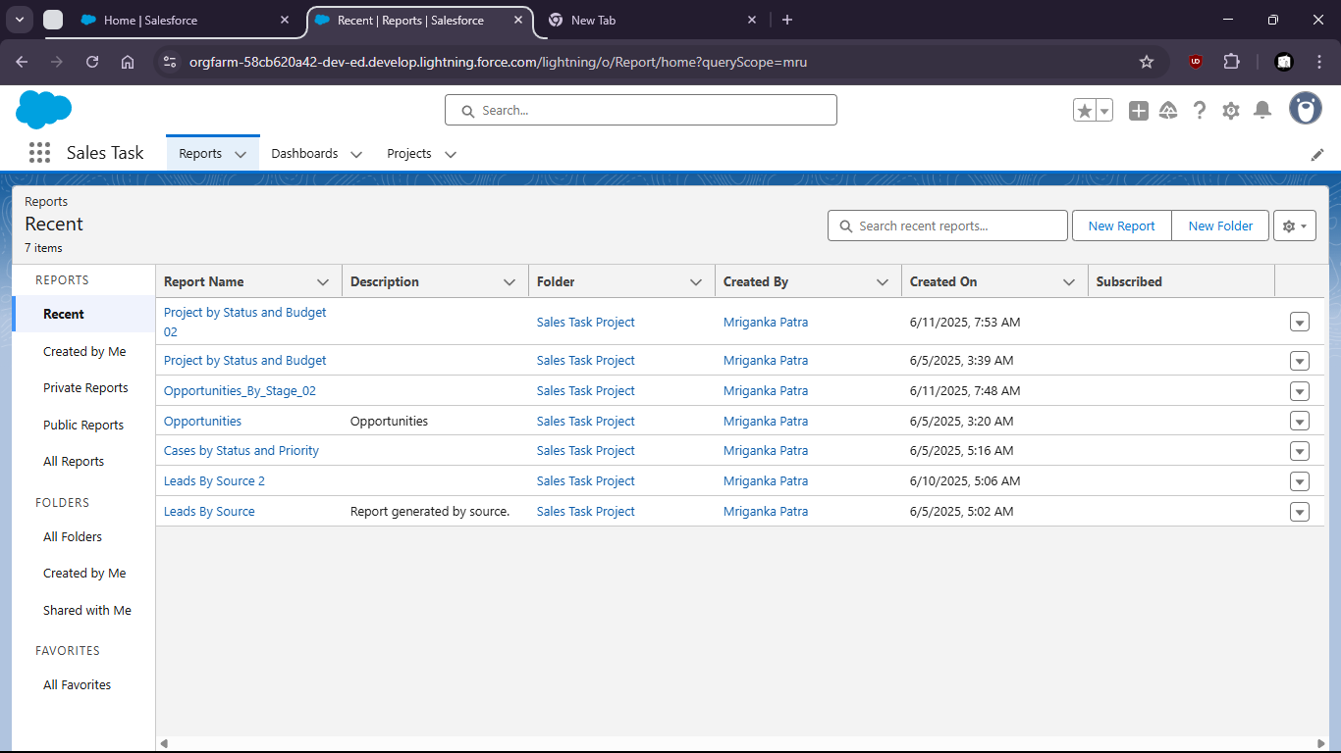
- Click on New Report
- Select Campaigns with opportunity

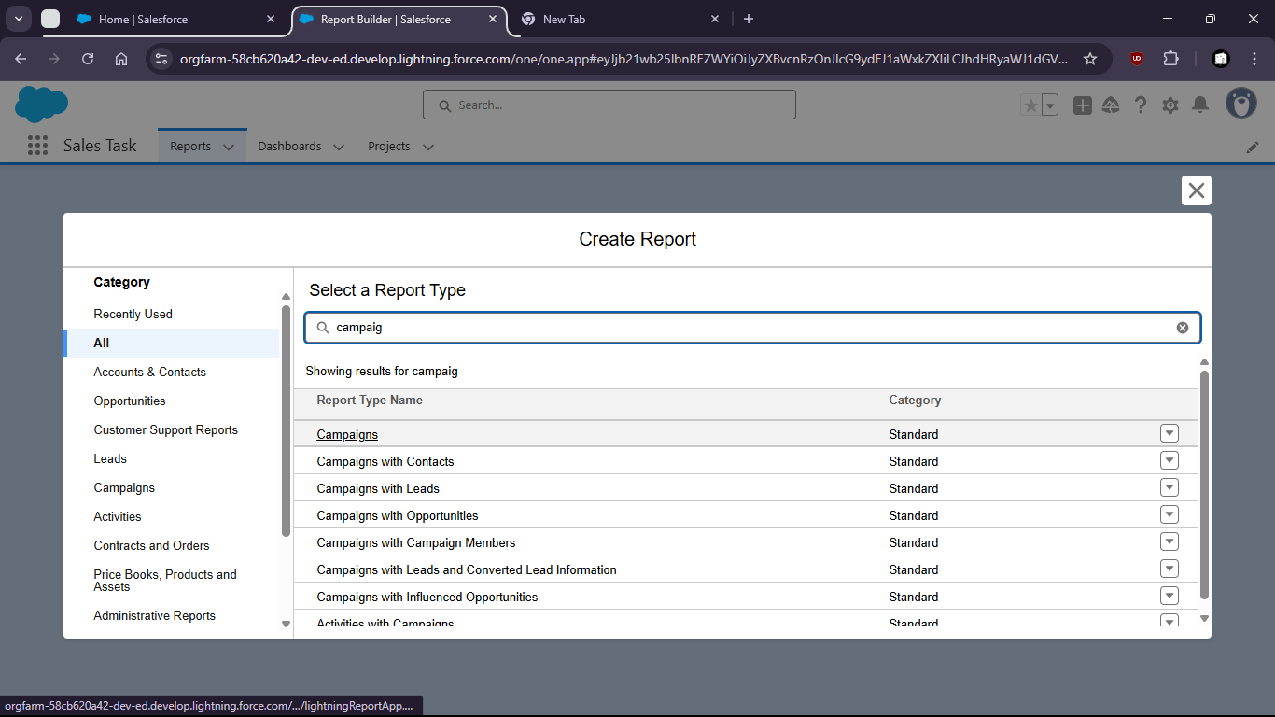

Task 3: Create 3 new Products with unique names and unique prices
- Go to the App Launcher and type "Products"

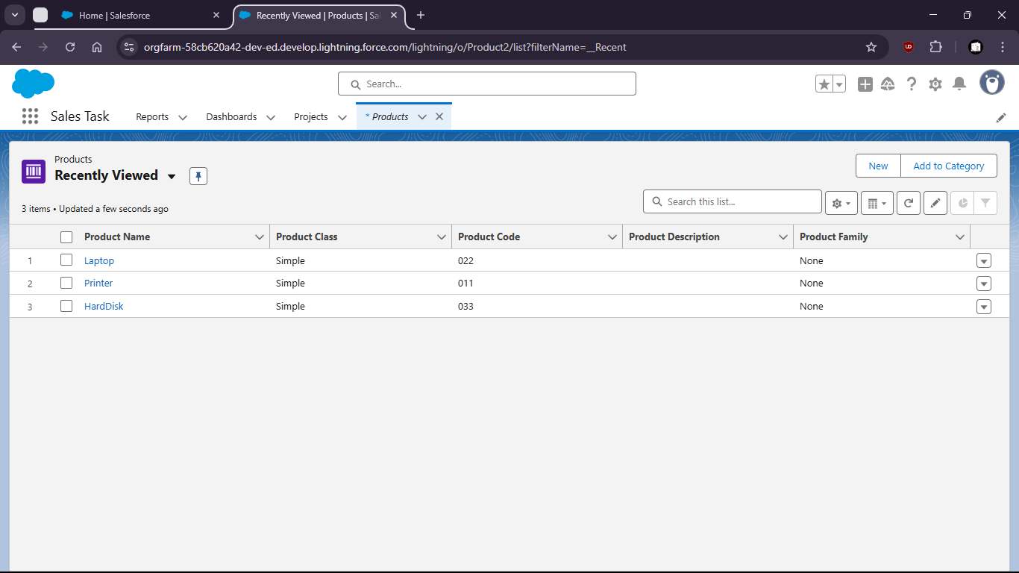
- Click on New and Create Product1
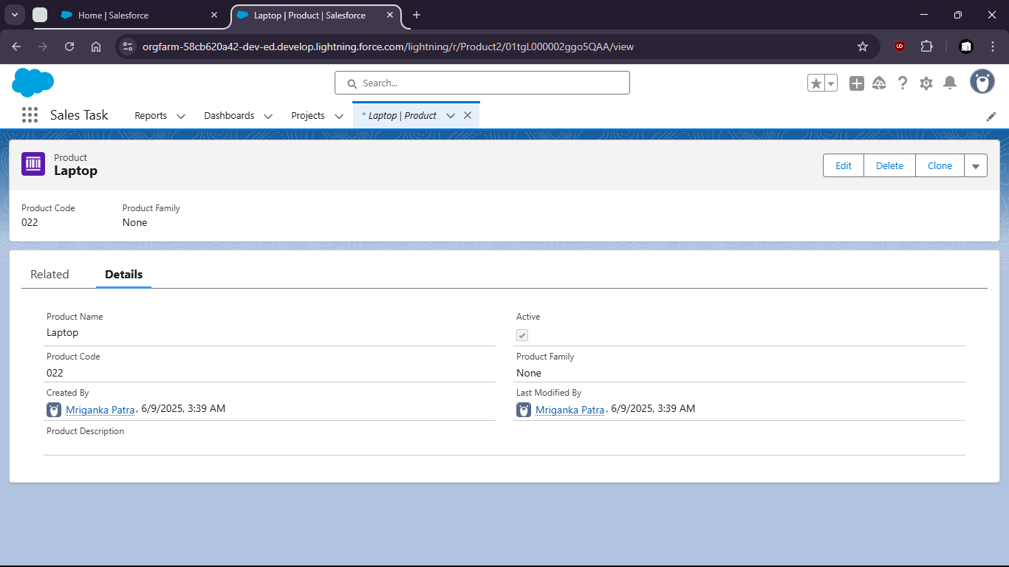
- Create Product#2
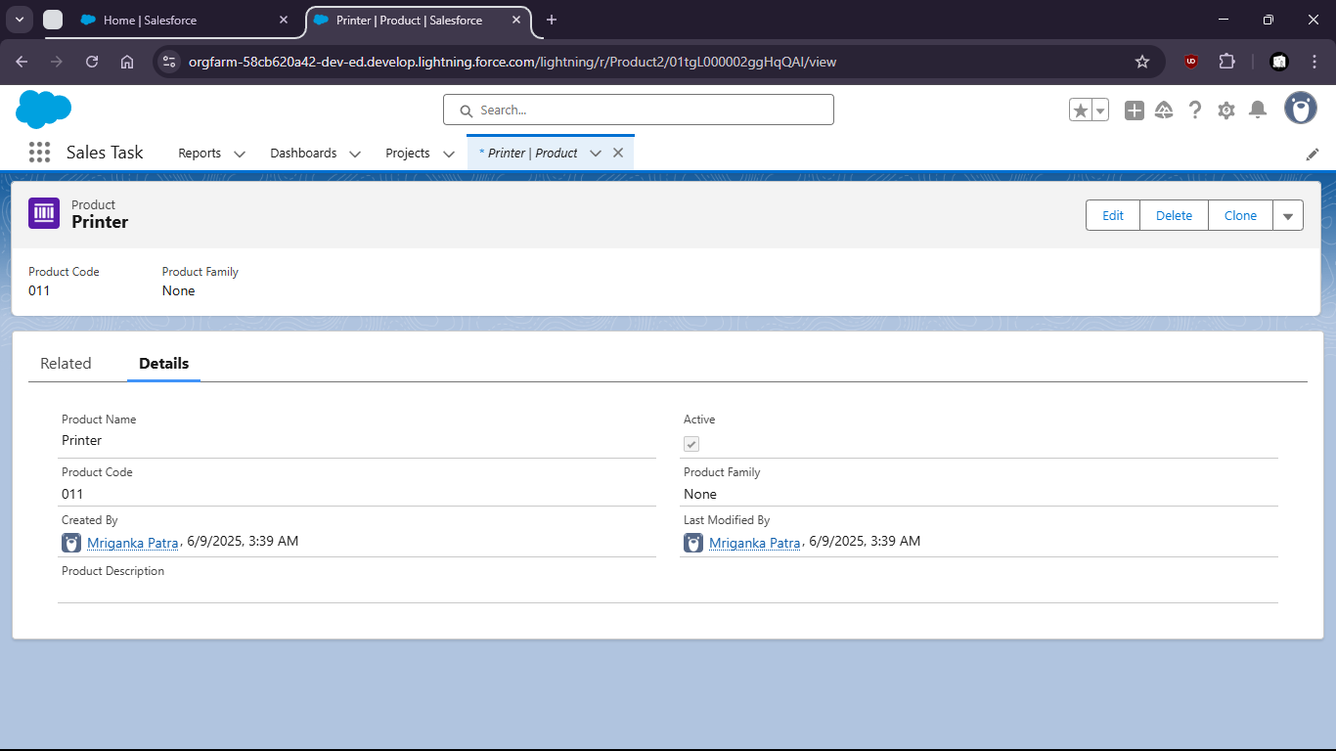

- Create Product#3
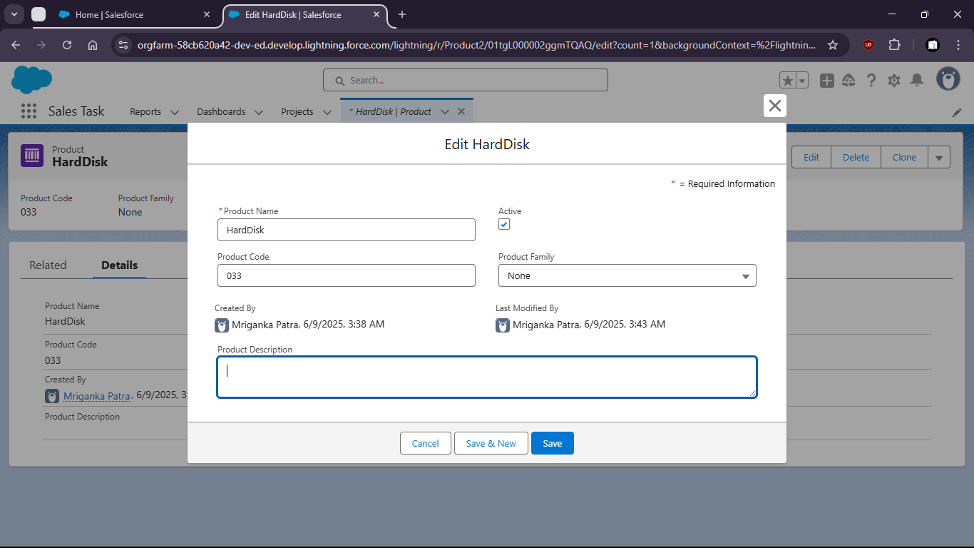
- All created Products
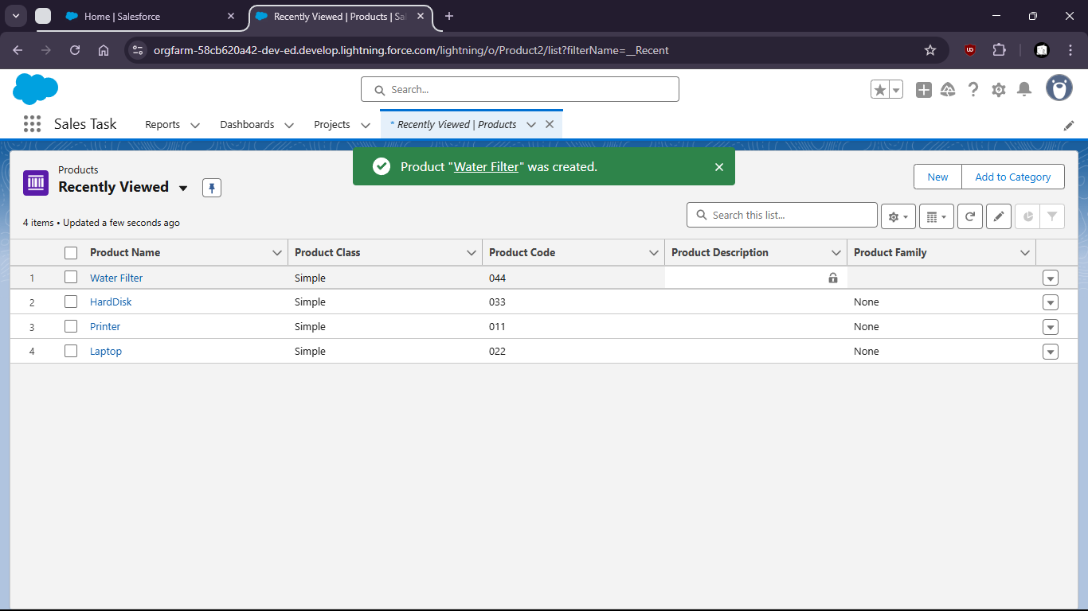
- Now open ‘Laptop’ product then go to ‘Related’
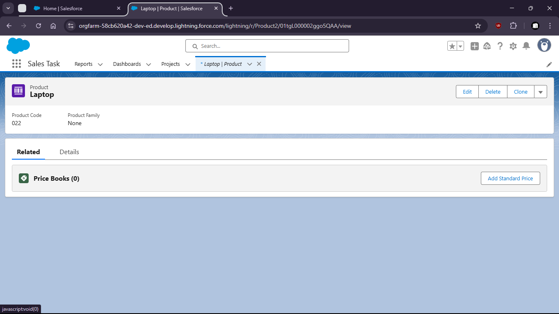
- Click on ‘Add Standard Price’ and add Price
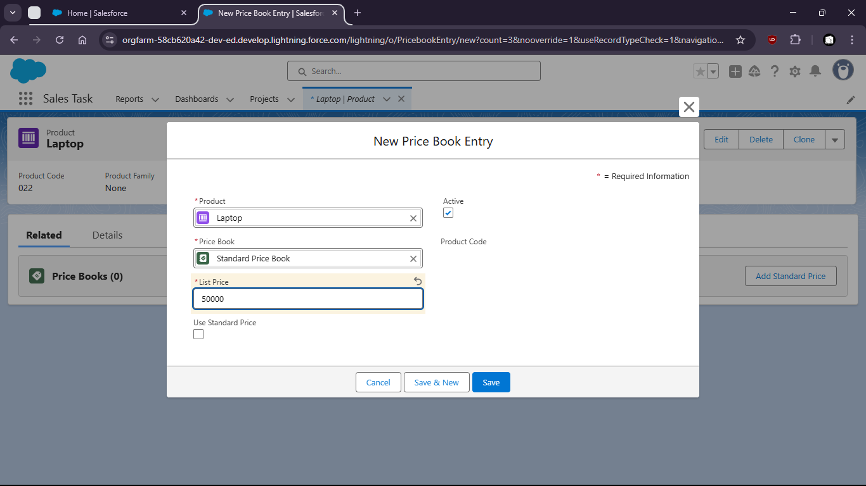

Task 4: Define custom Pricebook and associate the created products with different prices.
- Go to Pricebooks
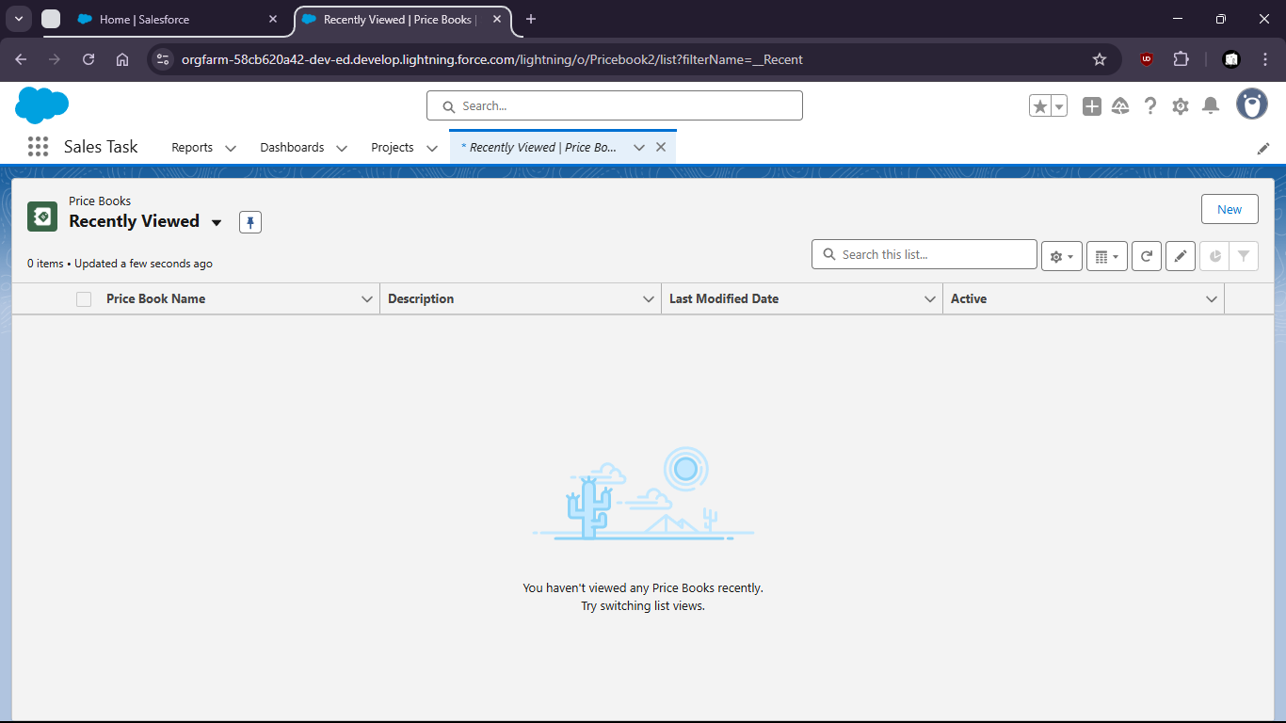
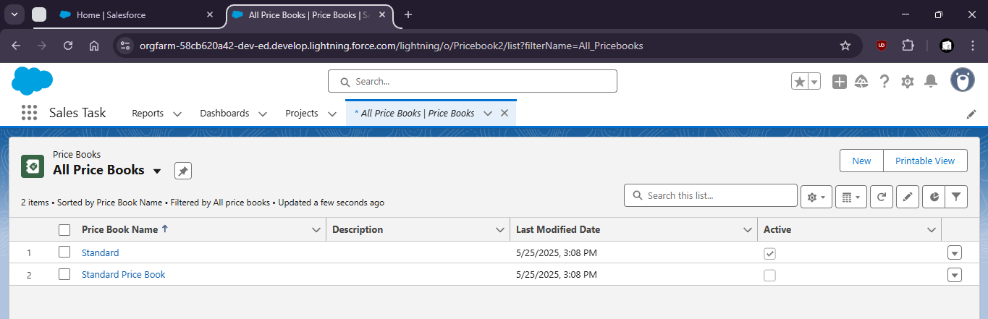
- Click New and create Summer Price Book
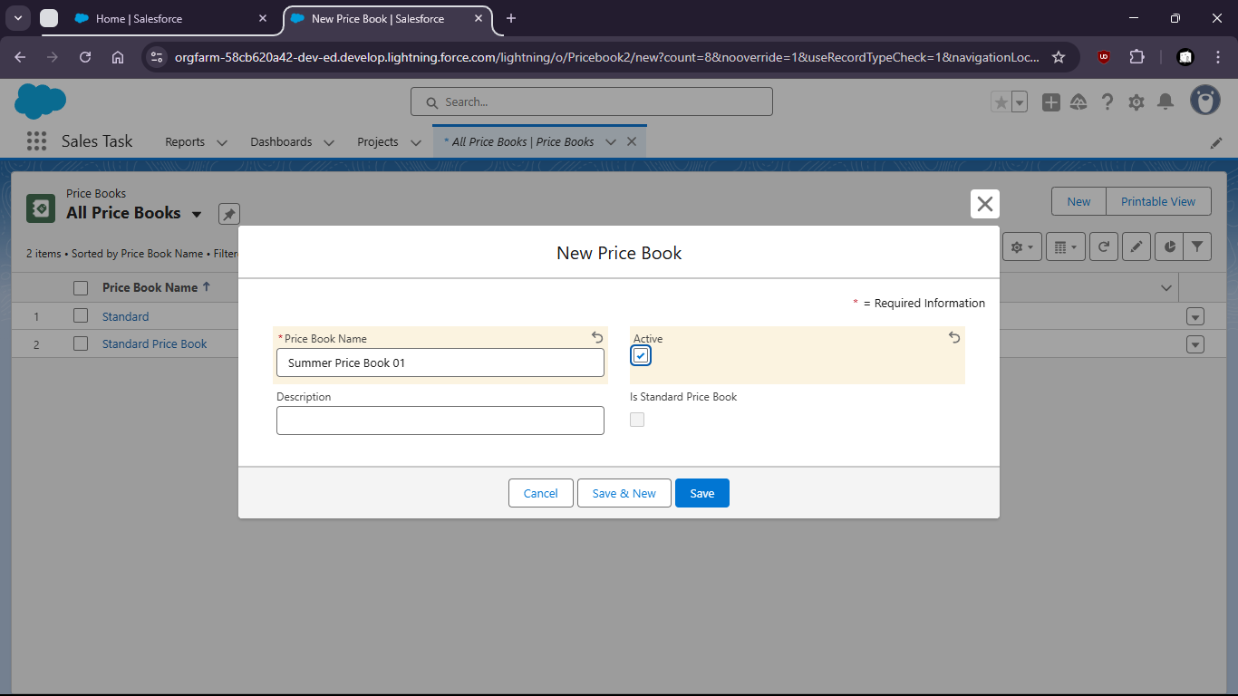
- Open the Price Book
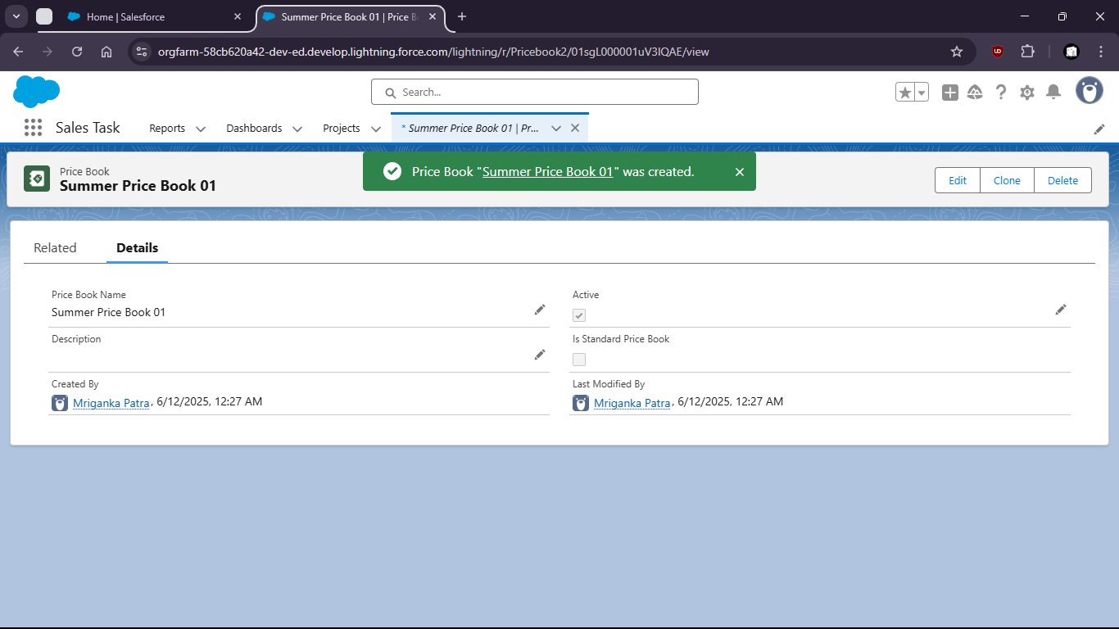
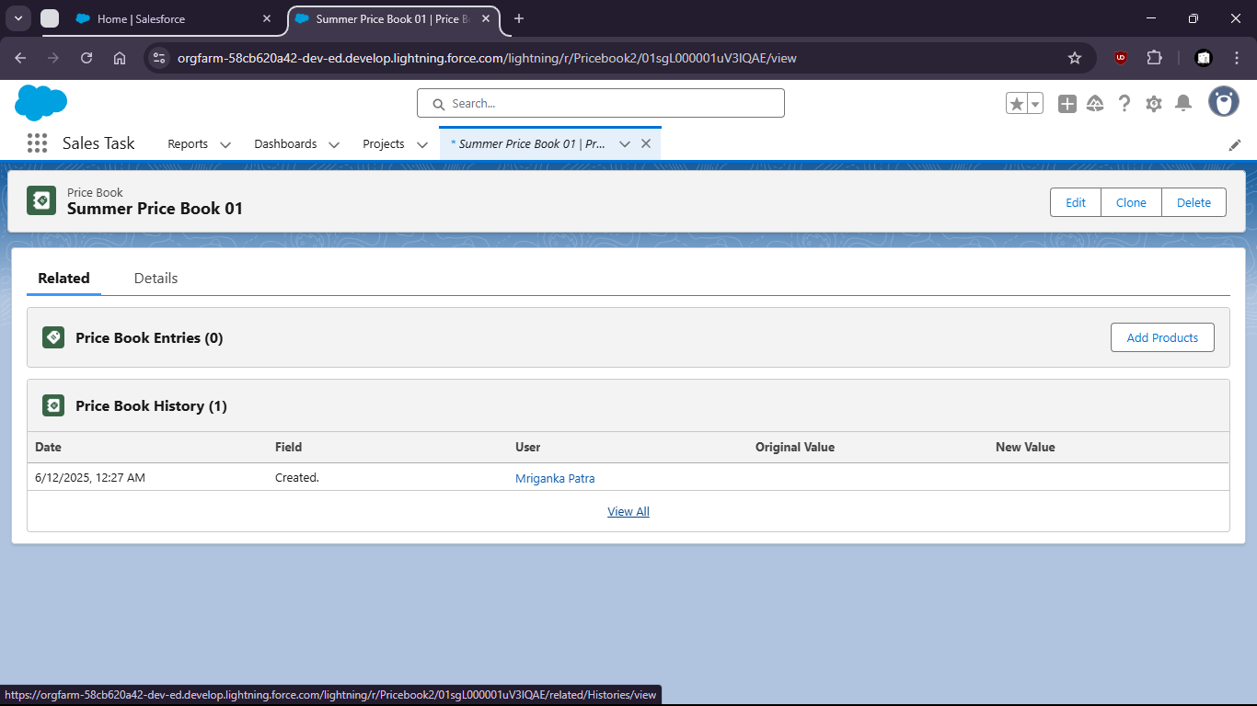
- Click on Add Products and select products
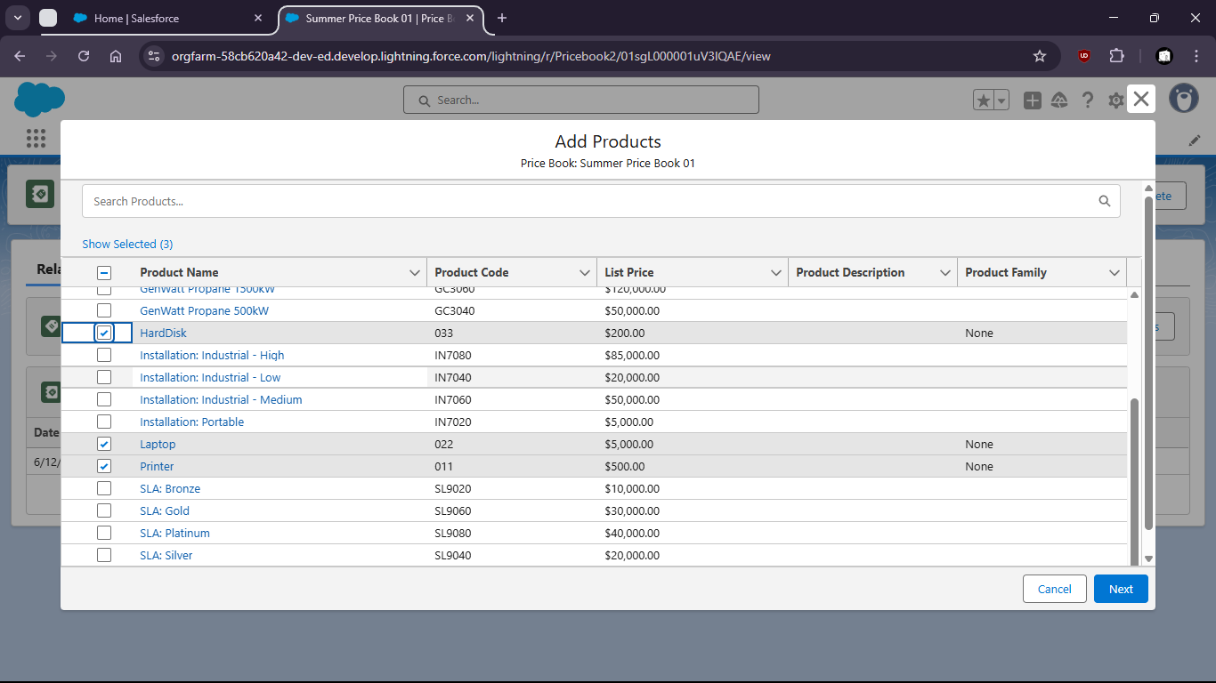
- Now save it
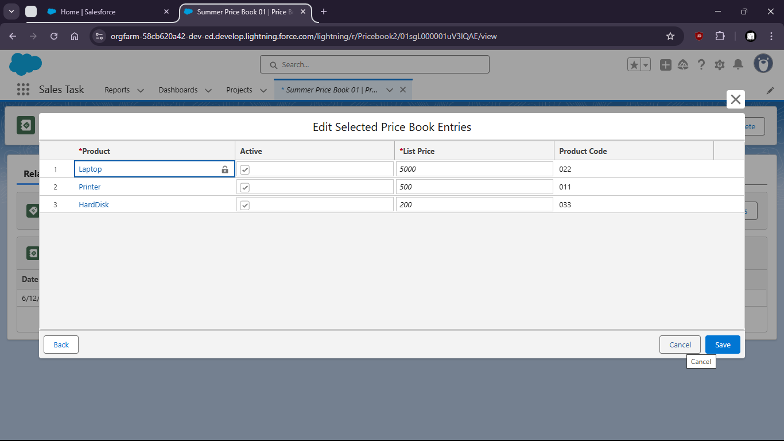
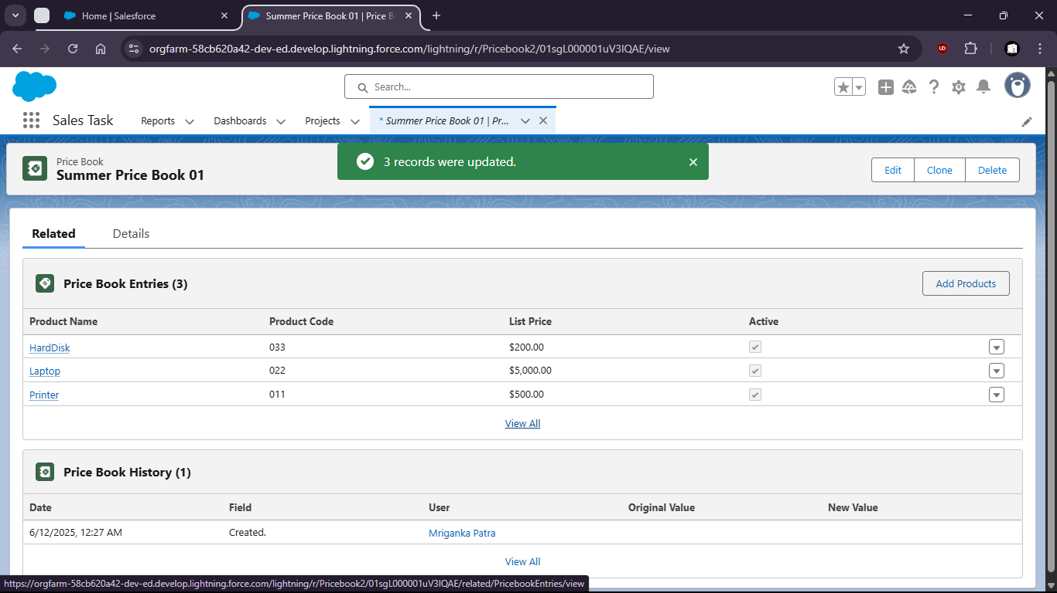

Task 5: Create an opportunity and add products using the custom ‘Pricebook’.
- Go to Opportunity by searching from App Launcher
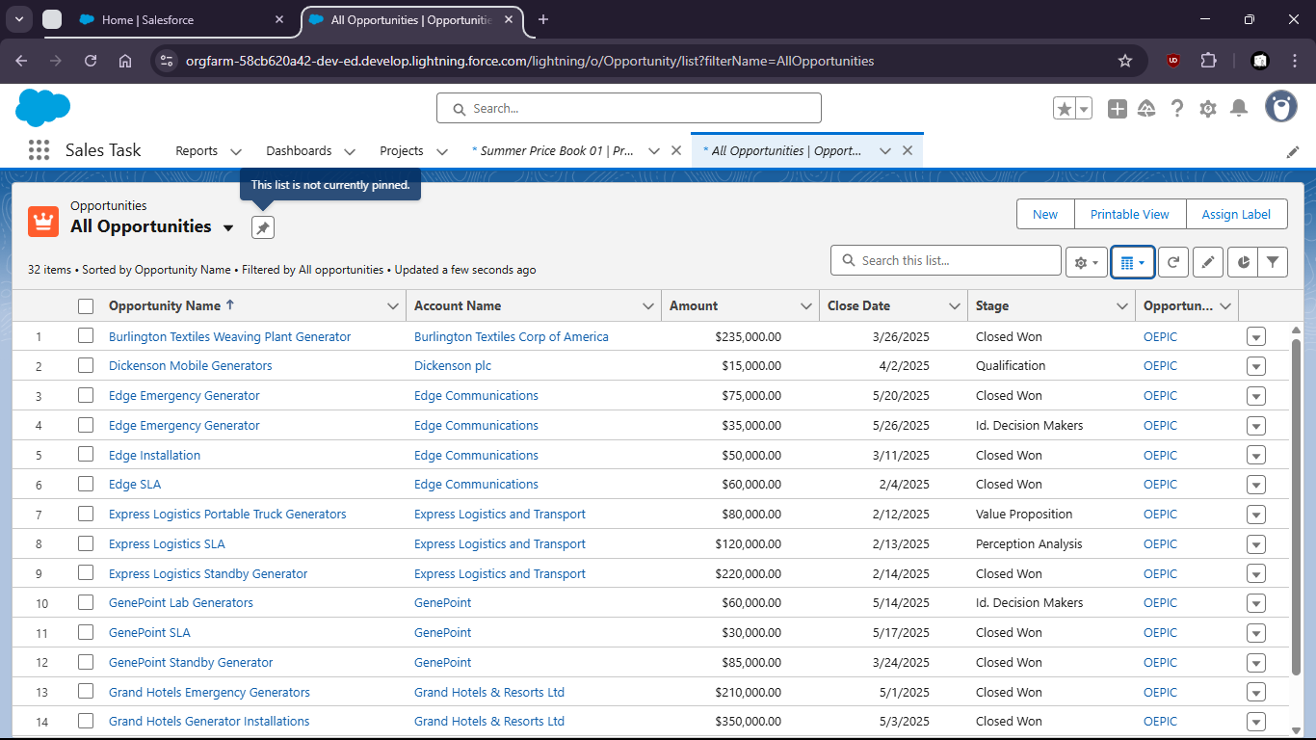
- Click New and create a new Opportunity
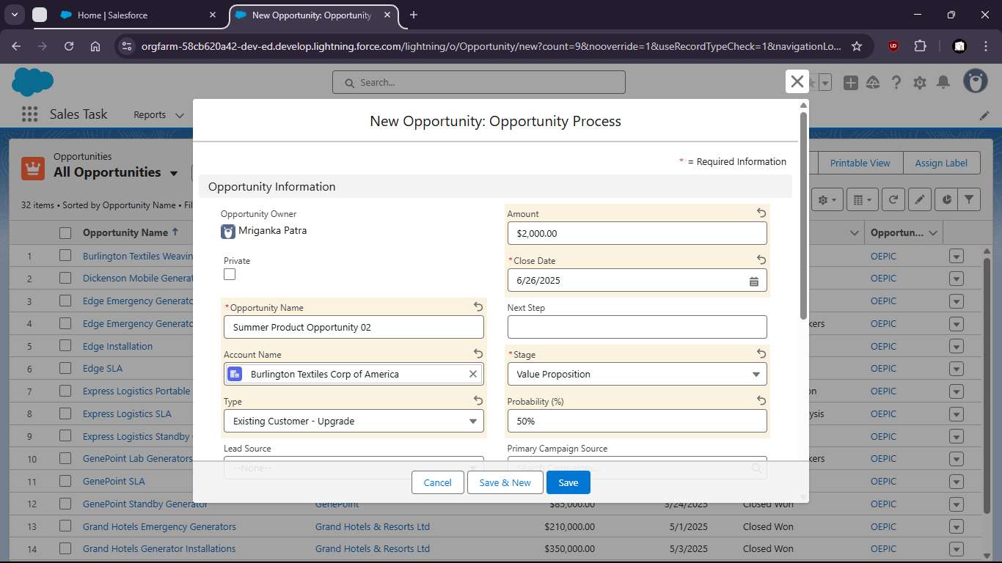
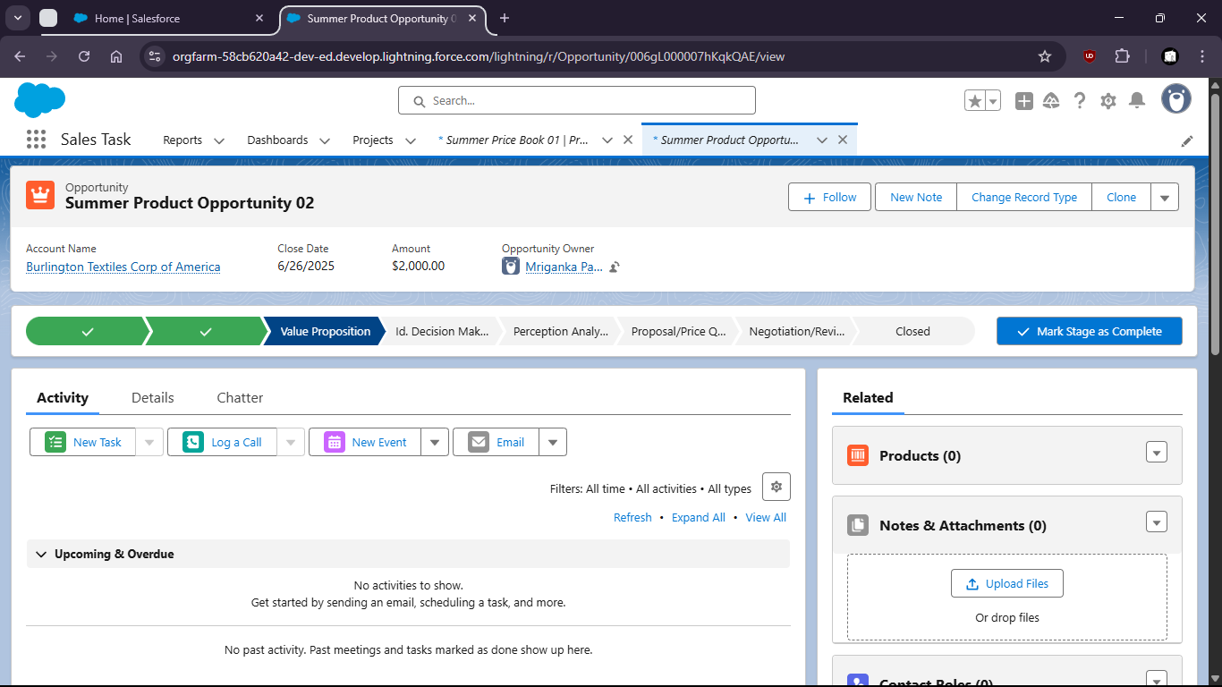
- Go to Products and click Add Product

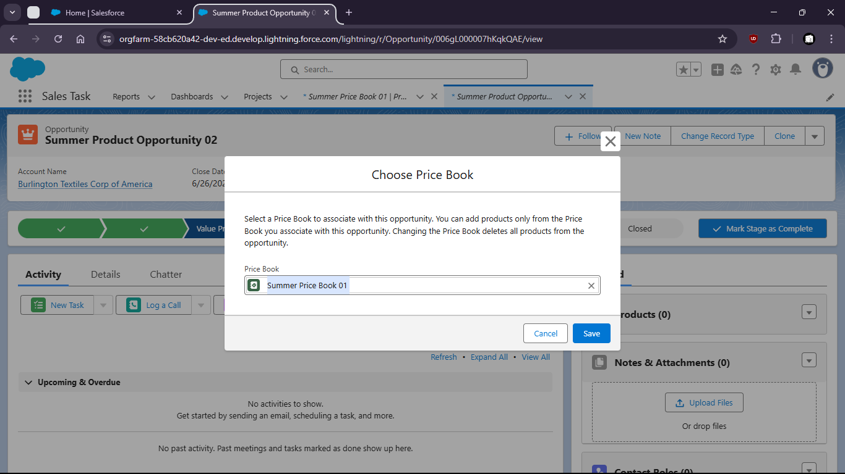
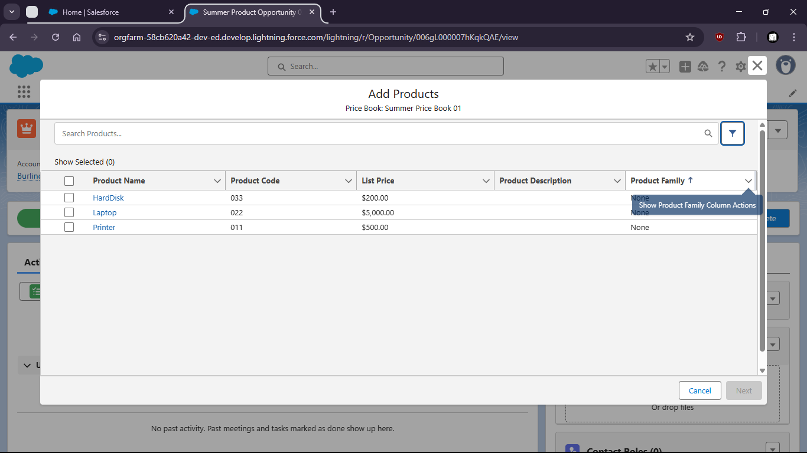

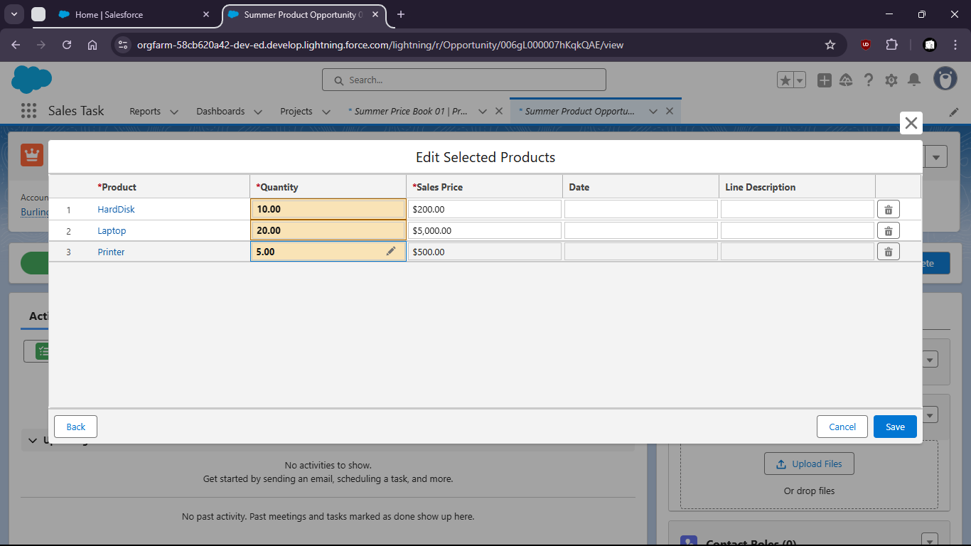
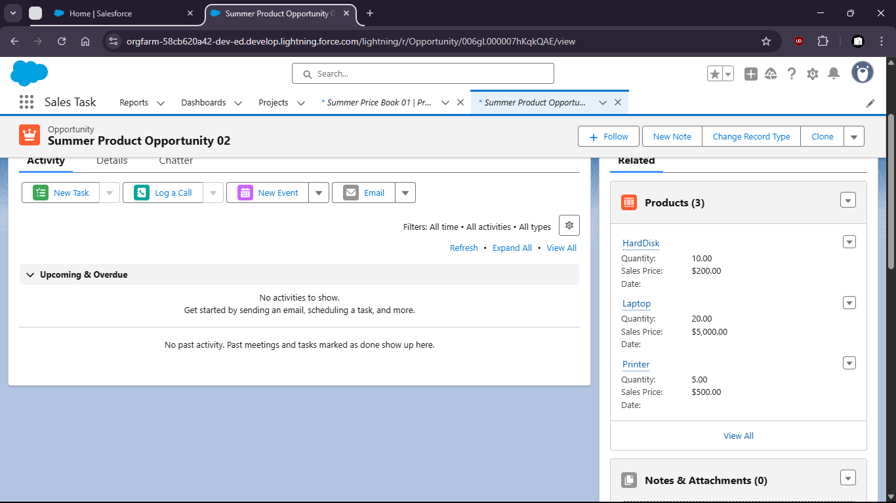

Task 6:

Task 7:

